Internet Computing

(ISTM-6205)

Final Project Report (GROUP-6)



**Website Development for:**

**JAVA HOUSE, WASHINGTON DC**

*Team Members:*

ANU JUNEJA

Table of Contents

1. Strategy 3

2. Scope and Structure: 3

a) Scope: 3

b) Structure: 3

3. Skeleton: 5

4. Surface 6

5. Implementation and Reflection 7

a) Future Directions 9

b) Lessons learned 10

6. References 10

7. APPENDIX-A 11

8. APPENDIX-B 14

8.1 CSS based image hover 14

8.2 Enhanced online shopping experience 15

8.3 Customer payment information validation 16

8.4 Order Number Generation 16

8.5 Online store timing management 17

9. APPENDIX-C 18

Table of Figures

Figure 1: Structure to the Scope- How will the pieces of the site fit together and behave. 4

Figure 2: Conceptual design layout of our proposed website 6

Figure 3: Directory Structure with details 7

Figure 4: Overall architecture diagram 9

# Strategy

We chose “[Java House DC](https://www.javahousedc.com/)” as our subject, which is a local coffee shop located in the heart of Washington, DC. We decided to rebuild it, as an attempt to make it aesthetically appealing, responsive, easily navigable and user friendly. To the business owners, this website should be helpful as an effective B2C (Business-to-Consumer) tool for increasing revenue, customer base and efficiently managing business processes.

The primary audience for the site is residents who are looking for a place to purchase coffee and refreshment items. The website aims to draw the primary audience in with photos, history, offering operating information (e.g., operating hours and location), and providing evidence of the legitimacy of the shop. The secondary audience is consumers who are interested in making online purchases. Customers can prepare their order in advance make payment and pick up the ordered items from the respective location.

# Scope and Structure:

## Scope:

Scope is where the strategies are transformed to requirements.

Taking our strategies into account, to enhance User Experience/User Interface, broadly speaking we divided desired website features into the following 2 categories.

1. **“MUST-HAVE” Features**:

* Faster response time
* Easy and intuitive navigation
* Efficiently yet visually appealing organization of the content.
* Scalability and Responsiveness (for different devices)
* Informative/ Intuitive Content
* Organized menu display with swift order placing capability
* Generating E-Receipt for better tracking.
* Attractive, cohesive design and layout.

1. **“NICE-TO-HAVE” Features:**

* Geolocation of the Store
* Social Media Links
* Image Gallery
* Contact/Feedback Page

## Structure:

Before an actual implementation launch, we made rough structure to decide about the overall architecture of the website, navigation/linking strategy, data flow, form validation criteria’s, image display placeholders.

In accordance with our objectives we ball parked different layouts for the website. The major challenge that we had in planning the structure was with the uniformity and effective navigation capability amongst different pages. Our goal was to minimize user confusion and avoid leaving them stranded on a page without an intuitive advancement path. For online shopping component, we put in extra effort to understand customer usage pattern, e.g. deleting and incrementing items in the cart, price display, ability to visualize item before purchase. We also put in extra attention to avoid pranksters and robots to artificially overload in our system with fake purchases.

Following is a chart explaining different layouts we brainstormed, tried, revised, improvised and tested:

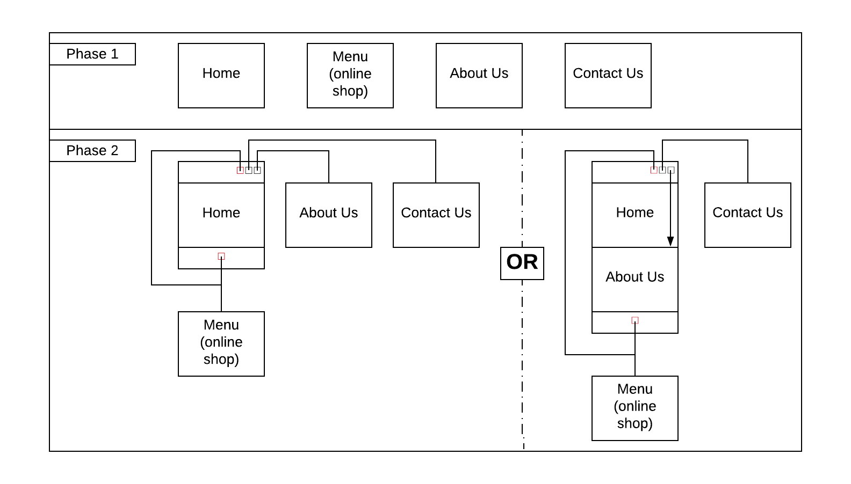

Figure 1: Structure to the Scope- How will the pieces of the site fit together and behave.

# Skeleton:

The skeleton is blueprint of an experience right before it takes final form. At the visual layer, this can be how elements are arranged so that users can interact with a system. We iteratively went through the design cycle and concluded on the following design skeletons for our web pages:

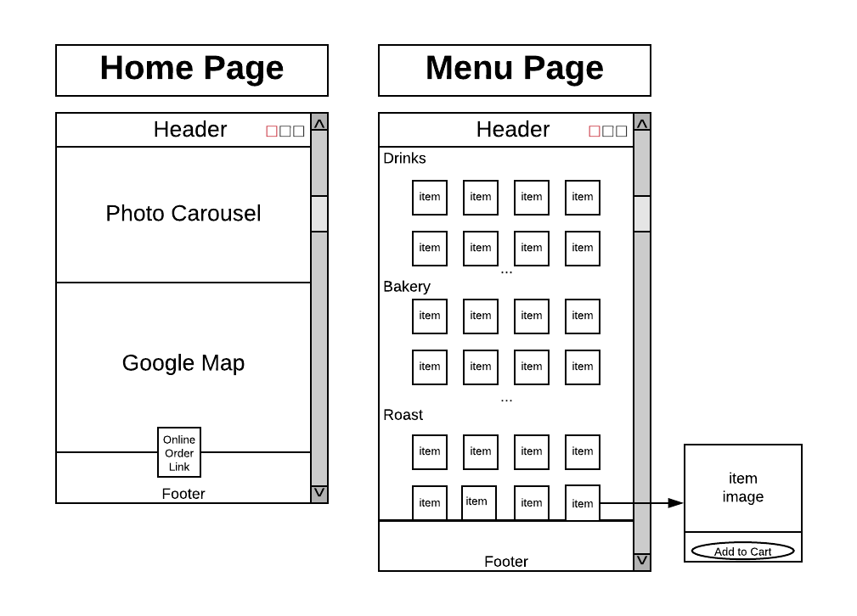

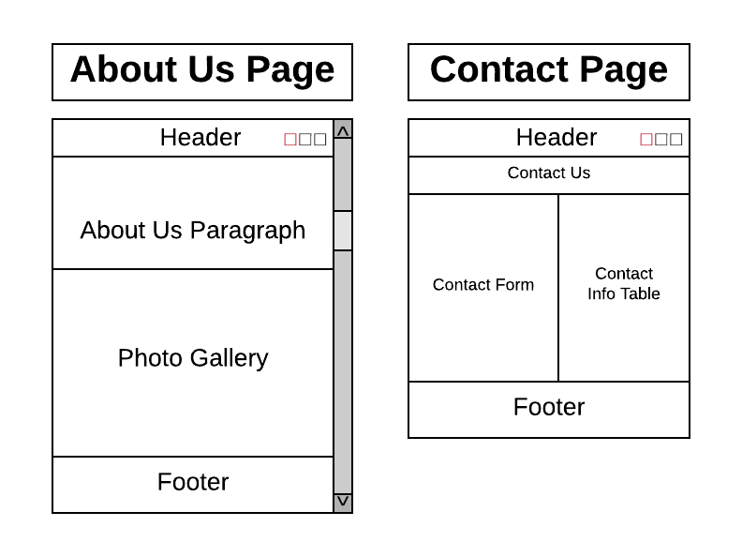

Figure 2: Conceptual design layout of our proposed website

# Surface

On disk, physical directory structure of our website looks like this:



Figure 3: Directory Structure with details

Please find the relative paths to the 4 fully functional HTML pages:

**“Home**” Page: /Group6_IC_FinalProject/home.html

**“Menu”** Page: /Group6_IC_FinalProject/menu.html

**“About”** Us Page: /Group6_IC_FinalProject/about.html

**“Contact:** Us Page: /Group6_IC_FinalProject/contact.html

# Implementation and Reflection

At high level, our software configuration consisted of the following:

* CSS Framework: Bootstrap v4.4.1

(<https://stackpath.bootstrapcdn.com/bootstrap/4.4.1/css/bootstrap.min.css>)

* JavaScript Libraries: jQuery v3.4.1

(<https://code.jquery.com/jquery-3.4.1.slim.min.js>)

* Popper.js v1.16.0

(<https://cdn.jsdelivr.net/npm/popper.js@1.16.0/dist/umd/popper.min.js>)

* Bootstrap.min.js v4.4.1

(<https://stackpath.bootstrapcdn.com/bootstrap/4.4.1/js/bootstrap.min.js>)

* jQuery form validation plugins

([https://cdn.jsdelivr.net/npm/jqueryvalidation@1.19.1/dist/jquery.validate. min.js](https://cdn.jsdelivr.net/npm/jqueryvalidation@1.19.1/dist/jquery.validate.%20min.js))

* jQuery additional methods “credit card” plugins

(<https://cdn.jsdelivr.net/npm/jquery-validation@1.19.1/dist/additional-methods.min.js>)

After our “almost final” design concept locked down, we discussed and laid down a basic look and feel the website will go by, like the fonts, highlights, borders, backgrounds, color schemes, and pictures. The navigation strategy and each page’s core components are reflected below (for ease of representation navigation from “thankyou.html” is not drawn:



Figure 4: Overall architecture diagram

For our styling, scaling and responsiveness needs, we used Bootstrap 4 throughout the website. Since Bootstrap 4 does not support Glyphicons, we used Font Awesome ([https://use.fontawesome.com/releases/v5.8.1 /css/all.css](https://use.fontawesome.com/releases/v5.8.1%20/css/all.css)) instead.

**Java Script Components:**

1. Image Carousel on the Home Page
2. Google Map API
3. Creating and Managing the Shopping Cart
4. Validation of Customer Details in Payment Information Modal Window
5. Generating an e-Receipt after a successful purchase

Header and footer Nav Bars are static on every web page and are designed to be the site’s Global Navigation Component using Bootstrap 4. It helps in connecting to the business’ social media links, out of which Java House has official pages at Facebook, Instagram, and Twitter (LinkedIn, Whatsapp and Snapchat are placeholders) and offer a shortcut for Online Purchase.

“Home” Page includes a bootstrap image carousel that asynchronously cycles through images and offers an initial indication of the site’s aesthetics. It also includes an interactive map centered around a marker placed at the coffee shop location using Google Maps JavaScript API, additionally, clicking on map marker shows some description about Java House.

“Menu” Page uses Bootstrap 4 image thumbnails to organize the items and make them look aesthetically appealing. It also uses Bootstrap4’s Modal window to show shopping cart and the Checkout form for customer details and payment information. There is a validation check on user entries using jQuery Validation Plugins.

On a successful purchase, website navigates to the “Thank You” page, where there is an e-Receipt with details of the purchase order, which is built using JavaScript and HTML form GET/POST methods.

“About” Page contains multiple paragraphs giving information about the coffee shop based on Bootstrap 4 styling sheets. It also includes a photo gallery that utilizes CSS styling, including image transitions, image transformation (blow up) when the mouse hover event is triggered.

“Contact” Page contains a form for feedback/ customer interaction with the business, along with information about the location and contact details of the business. It utilizes form and card from Bootstrap 4 Framework.

Please see APPENDIX-A for before and after website comparison.

Please see APPENDIX-B for website features.

Please see APPENDIX-C for online store order management feature.

## Future Directions

* “Menu” page has the most potential for expanding. In future, we would like to have a more extensive checkout system, which would include shipping options for non-perishable items like coffee beans.
* Allowing customers to click on individual products and get more details.
* Addition of customer review capability.
* Customer capability for creating individual accounts.
* Allowing product comparison.
* Adding customized orders like “create your own” brews or other personalized products to help Java House stand out amongst other coffee shops.
* Enhance JavaScript code, offering semi-automatic inventory management and “Menu” page updates like new product addition, price changes, best sellers, discontinuing low selling products etc. for Java House website admin.
* Taking this site live after Java House management’s agreement after integrating an email and SQL server.

## Lessons learned

* We learned debugging tools like “Chrome Dev tools” for Chrome and “Developer Tools” for Edge as a powerful means to step through JavaScript code and alter HTML/CSS in runtime.
* We as a team saw the vision of a rustic, personal aesthetic of the site. The consistency of the different pages worked very well. We were able to contribute to each other’s strengths and build on top of each other’s contributions.
* We as a team were mesmerized by the power of JavaScript, it works wonders, as a tool for client-side functionality. Online cart management and “thank you” page is an excellent example supporting our observation.
* One of the main challenges, was coordinating amongst team members working on a shared file. Coordinating a more definitive timeline would have helped avoid some overlap and tools like GitHub would have assisted in version and configuration management.
* It was a great opportunity to learn how to design and develop a website by channeling diverse ideas together and seeing them grow in a concurrent development environment.

# References

1. Java House DC. (n.d.). Retrieved from <https://www.javahousedc.com/>
2. Chrome DEV tools from <https://developers.google.com/web/tools/chrome-devtools/>
3. Bootstrap 4 documentation from <https://getbootstrap.com/docs/4.4/getting-started/introduction/>
4. jQuery documentation from <https://api.jquery.com/>
5. jQuery validation plugins documentation <https://jqueryvalidation.org/documentation/>
6. Google MAPs Javascript API documentation from <https://developers.google.com/maps/documentation/javascript/tutorial>
7. Font Awesome documentation from <https://fontawesome.com/how-to-use/on-the-web/referencing-icons/basic-use>

# APPENDIX-A

This section will give a pictorial overview of comparison between Java House, Washington DC’s current (on left side) and our group’s proposed design (on right side):

**HOME PAGE:**

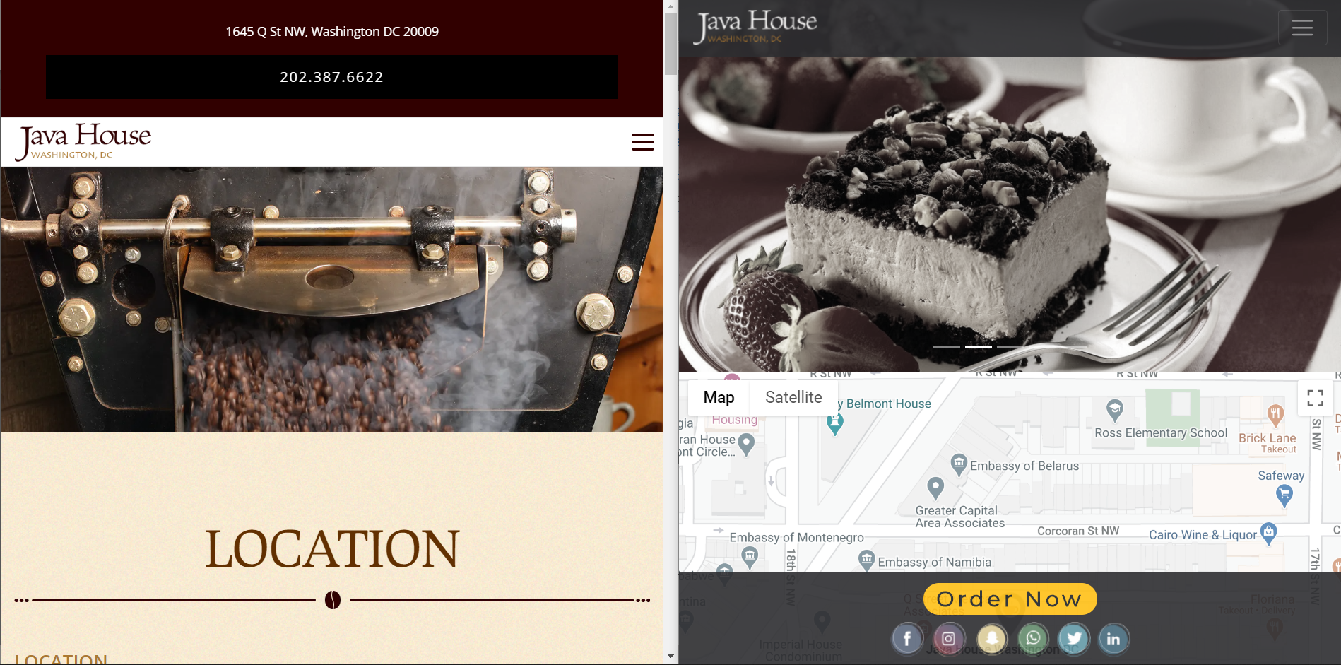

**MENU PAGE:**

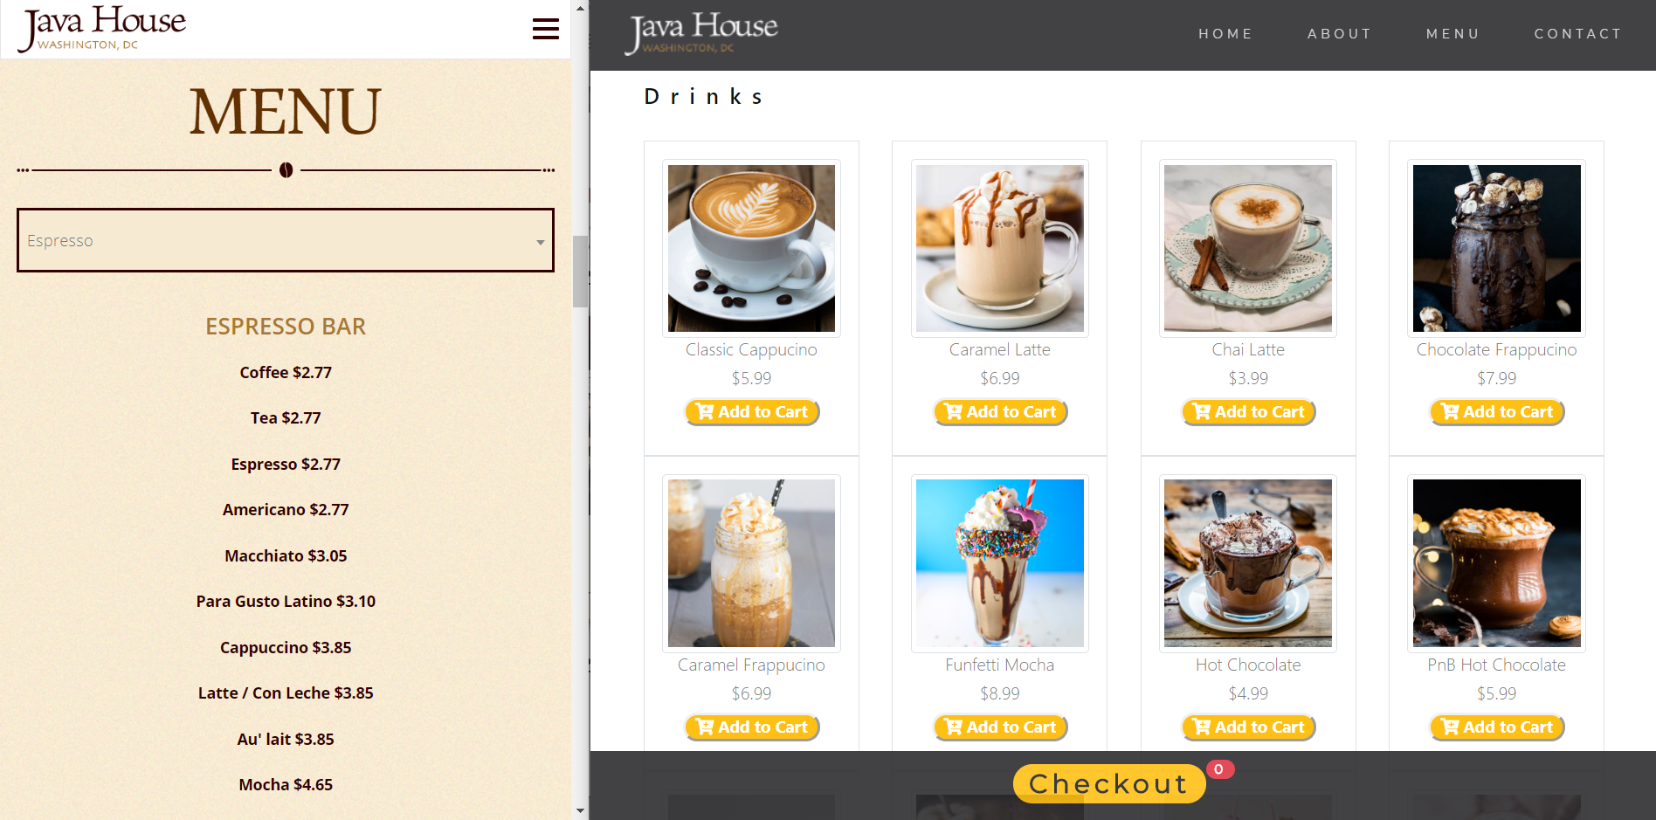

**ONLINE ORDER PAGE:**

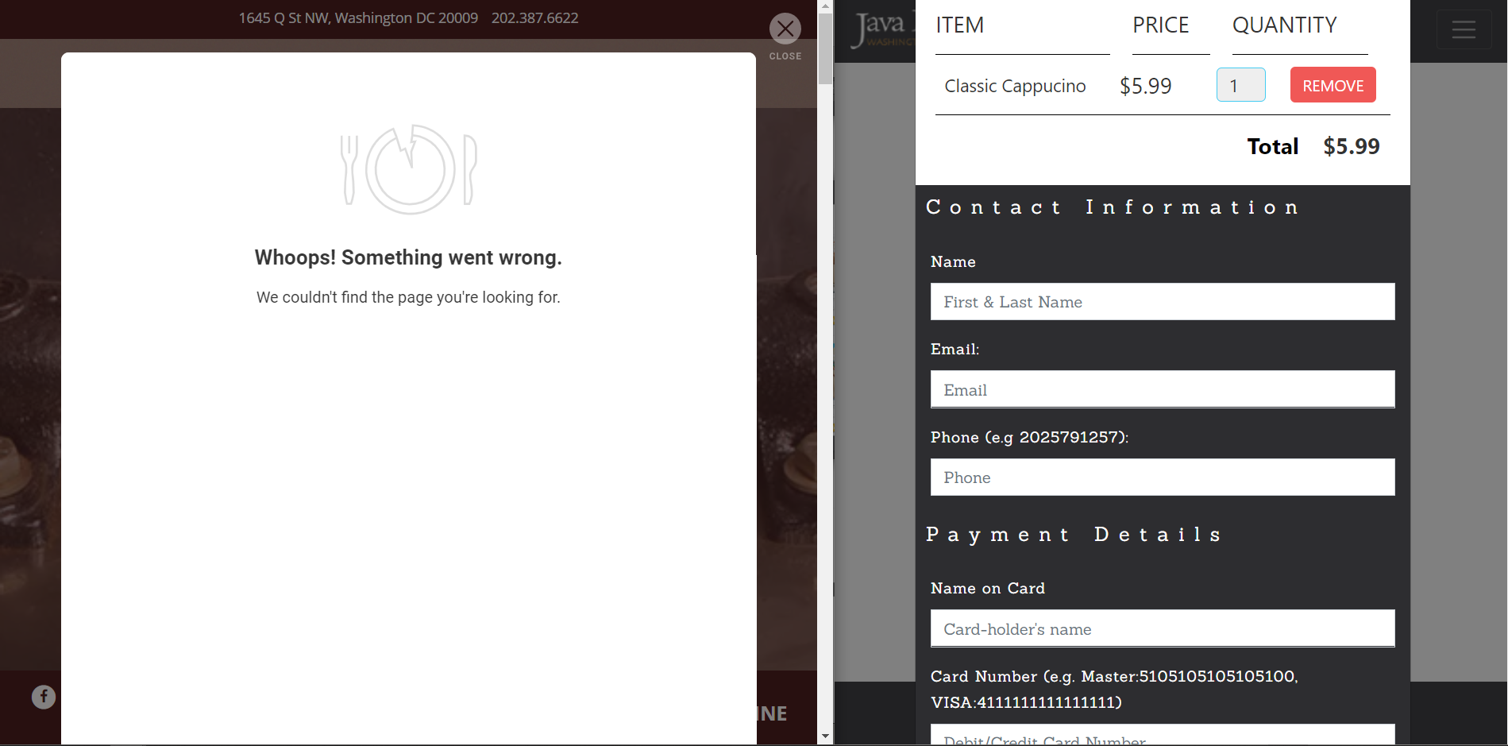

**ORDER CONFIRMATION PAGE:**

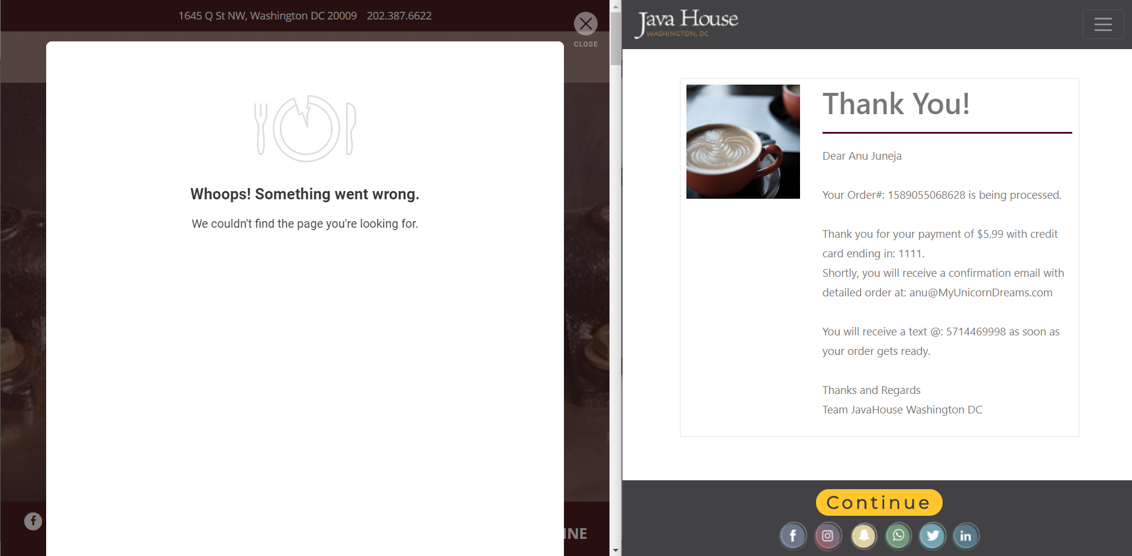

**ABOUT PAGE:**

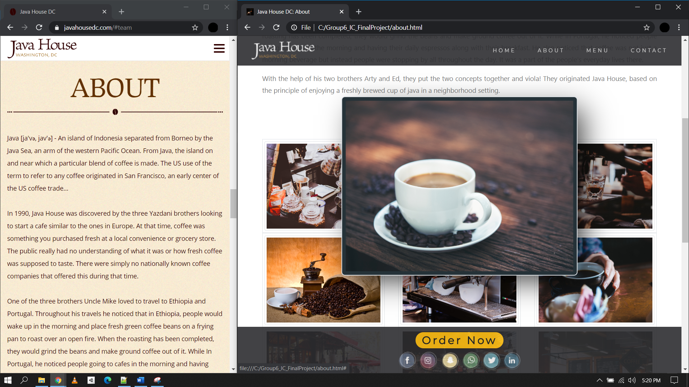

# APPENDIX-B

Some of the new features developed under our project and are worth mentioning:

## CSS based image hover

In “About” page, for enhancing customer experience, we added CSS based mouse over image blow up feature, as shown below:

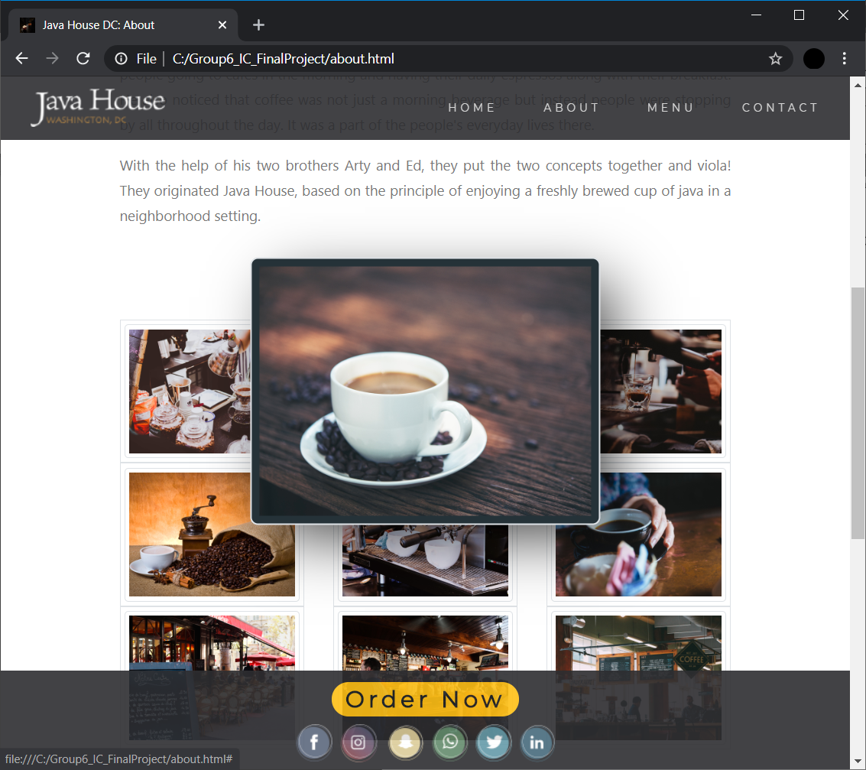

## Enhanced online shopping experience

In “Menu” page, for ease of shopping and in order to make things exciting we added thumbnails of the products with “Add to Cart” option right next to them, also, customer can see the number of items in their cart right away, as shown below:

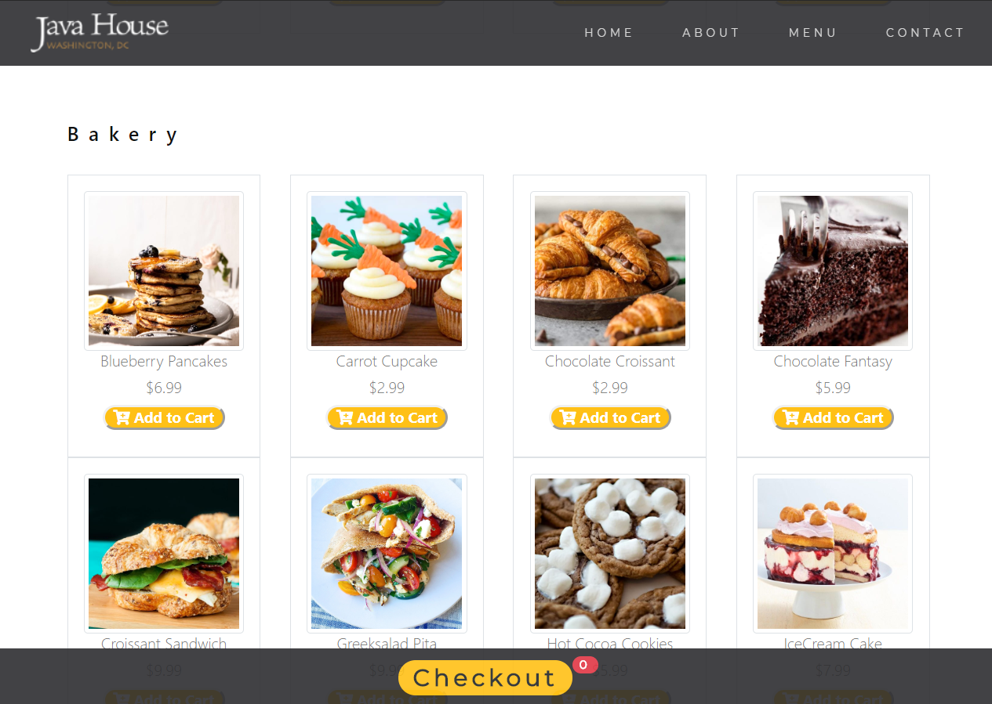

## Customer payment information validation

In “Menu” page, after clicking on “Checkout” button we added a validation feature in order to avoid robos and bots from sending bogus information and ensuring customers send correct information to avoid transaction delays later, as shown below:

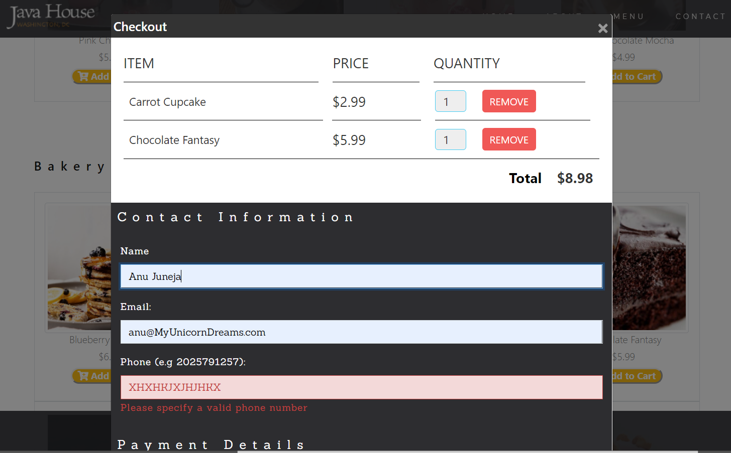

## Order Id Generation

Every time a customer places an order on the website, he will get a unique order id generated by current date and time in milliseconds. This has been achieved by creating a JavaScript function for the same.

## Online store timing management

Since we are offering order ahead option, the website manages order acceptance only during the store open hours, as shown below for e.g. current time is between store opening hours which are 8AM to 8 PM EST, the Menu page looks like below:



But, if the same page is opened outside of operation hours, the Checkout button is replaced with store open hours text, see below:

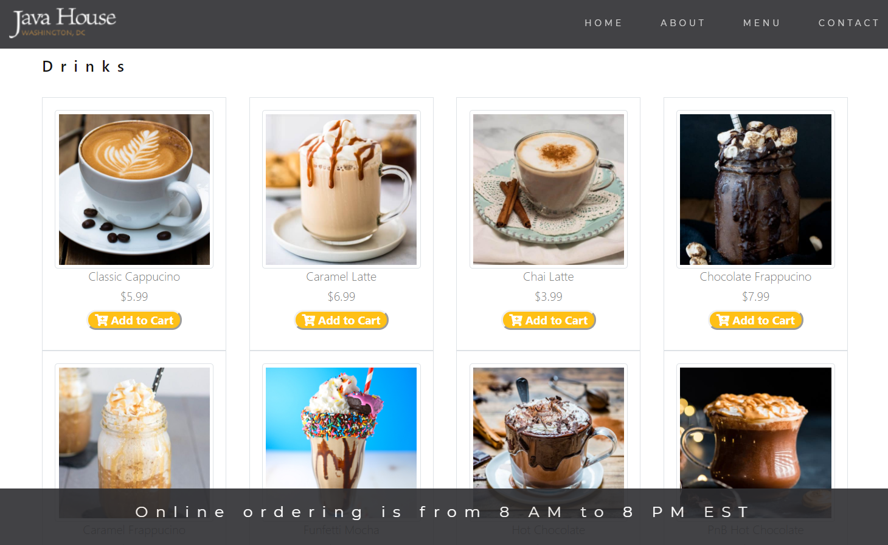

# APPENDIX-C

Based on 8.4 above, our website’s JavaScript interfaces with PC time in order to understand the current time and only if it is between 8AM to 8 PM EST, the checkout button is activated, else user sees a note “Online ordering is from 8 AM to 8 PM EST”. For evaluating this feature, we suggest changing your PC clock to any time you want to test our website against and then wait for 3 minutes to open the “Menu” page or refresh any current page. Wait of 3 minutes is needed after every PC time clock change because, WINDOWs timing services need some time to send time synchronization messages to the browser services.